Restaurant Cuisine Classification using Machine Learning

Machine Learning Internship Project Report

Submitted to: Cognifyz Technologies

Submitted By: Dixa

Course: B.Tech Computer Science Engineering (AI & ML)

Date: 12 July, 2026

1. Introduction
Machine Learning classification techniques are widely used to categorize data into predefined classes. In the restaurant industry, identifying the cuisine type of a restaurant is useful for search engines, food delivery applications, recommendation systems, and customer analytics.
This project focuses on developing a classification model capable of predicting the primary cuisine of a restaurant based on various restaurant characteristics.

2. Problem Statement
Many restaurants offer multiple cuisines, making cuisine identification challenging. Automatically classifying restaurants into their primary cuisine category can simplify restaurant organization and improve recommendation systems.
This project aims to build a machine learning classification model capable of predicting the primary cuisine of restaurants using available restaurant attributes.

3. Objectives
The objectives of this project are:
- Build a machine learning classification model for restaurant cuisine prediction.
- Clean and preprocess the dataset.
- Handle missing values.
- Select the primary cuisine as the target variable.
- Encode categorical variables.
- Train a Random Forest Classification model.
- Evaluate model performance using classification metrics.
- Analyse the most influential features affecting cuisine classification.

4. Dataset Description
The dataset contains restaurant information collected from different cities and countries.
Dataset Summary
- Total Records: 9551
- Total Features: 21
- Target Variable: Primary Cuisine
Important Features
- Country Code
- City
- Average Cost for Two
- Currency
- Price Range
- Customer Votes
- Has Table Booking
- Has Online Delivery
- Is Delivering Now
- Primary Cuisine

5. Data Preprocessing
The following preprocessing steps were performed before training the classification model:
- Loaded the restaurant dataset.
- Checked dataset dimensions and data types.
- Identified missing values.
- Filled missing values in the Cuisines column.
- Extracted the Primary Cuisine by selecting the first cuisine listed for each restaurant.
- Removed cuisine classes containing very few samples to improve model stability.
- Encoded categorical variables using LabelEncoder.
- Split the dataset into training and testing datasets.
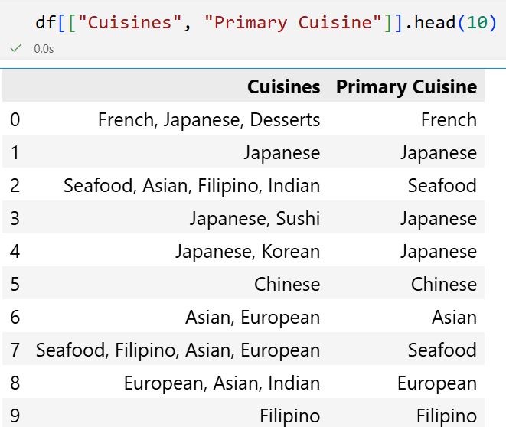

6. Exploratory Data Analysis
Exploratory Data Analysis (EDA) was performed to understand the characteristics of the dataset.

7. Feature Engineering
The following features were selected for classification:
- Country Code
- City
- Average Cost for Two
- Currency
- Has Table Booking
- Has Online Delivery
- Is Delivering Now
- Price Range
- Votes
The target variable used for prediction was:
Primary Cuisine
All categorical variables were converted into numerical values using Label Encoding.
The dataset was divided into:
- Training Data: 80%
- Testing Data: 20%

8. Machine Learning Model
A Random Forest Classifier was selected for this project.
Random Forest is an ensemble learning algorithm that combines multiple decision trees to improve prediction accuracy and reduce overfitting.
Advantages
- Handles mixed data types.
- Works well with categorical and numerical features.
- Provides feature importance.
- Produces reliable classification performance.

9. Model Evaluation
The classification model was evaluated using the following metrics:
- Accuracy
- Precision
- Recall
- F1-Score
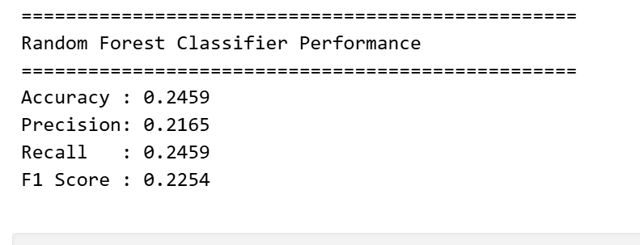

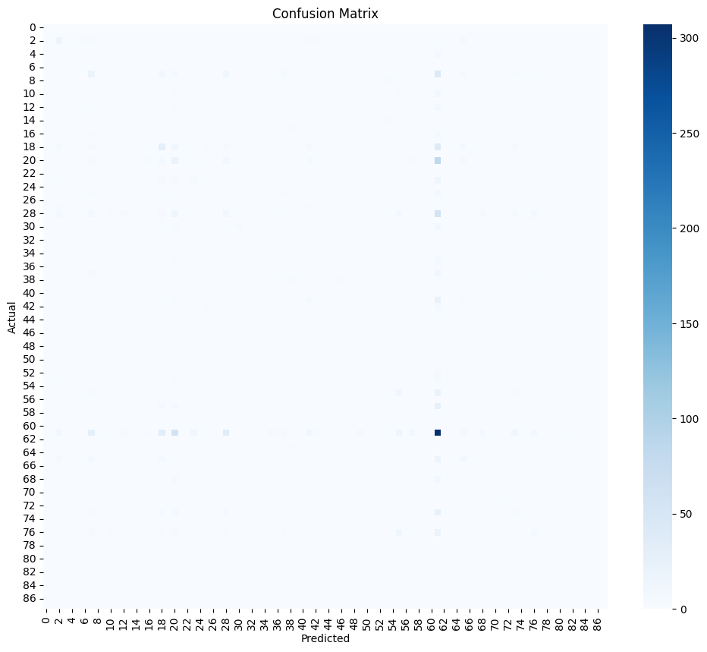

10. Feature Importance
Feature importance analysis was performed to determine which restaurant attributes contributed most to cuisine prediction.
The Random Forest model identified features such as customer votes, price range, average cost, and city as important predictors.
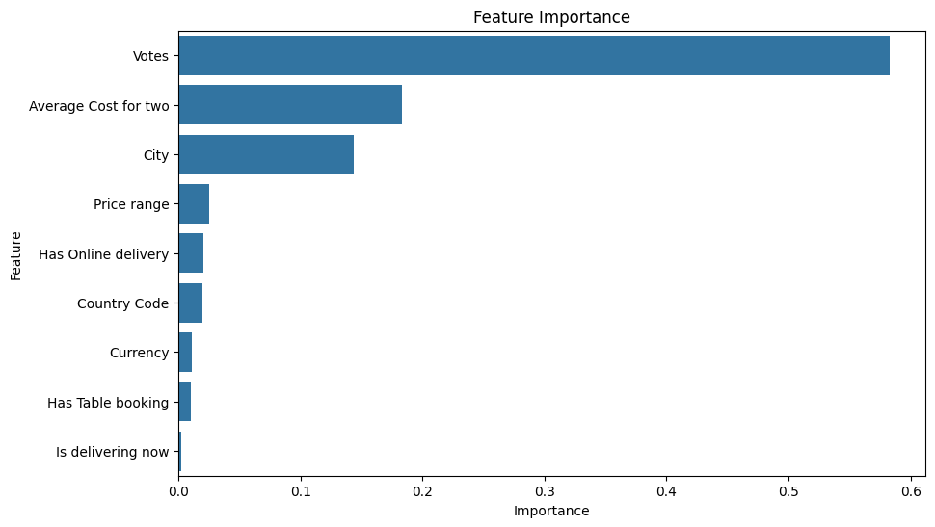

11. Results
The Random Forest Classifier successfully classified restaurants into their primary cuisine categories.
The model achieved satisfactory classification performance based on Accuracy, Precision, Recall, and F1-Score.
The project also demonstrated that restaurant characteristics such as customer votes, price range, and location significantly influence cuisine prediction.

12. Conclusion
This project successfully developed a machine learning classification model capable of predicting the primary cuisine of restaurants.
The dataset was preprocessed by handling missing values, selecting the primary cuisine, encoding categorical variables, and removing rare cuisine classes. A Random Forest Classifier was trained and evaluated using multiple classification metrics.
The project demonstrates the effectiveness of machine learning techniques for restaurant cuisine classification and provides a strong foundation for developing intelligent restaurant search and recommendation systems.

13. Future Scope
The project can be enhanced by:
- Hyperparameter tuning of the Random Forest model.
- Applying Cross Validation for better evaluation.
- Experimenting with advanced classifiers such as XGBoost, LightGBM, and CatBoost.
- Developing a Multi-Label Cuisine Classification system.
- Deploying the model as an interactive web application.
- Integrating the model into restaurant recommendation platforms.

14. References
- Scikit-learn Documentation
- Pandas Documentation

